# Ethical Issues in Business Organization

Ibrahim Khalil, Tulshi Chandra Das, Maloy Kanti Sarker

Students of Institute of Information Technology, University of Dhaka.

bsse0804@iit.du.ac.bd, bsse0811@iit.du.ac.bd, bsse0834@iit.du.ac.bd

[Rezvi Shahariar](http://www.iit.du.ac.bd/about_iit/individual_teacher/51)

Assistant Professor,

Institute of Information Technology, University of Dhaka

**Abstract:** Ethics in business organizations has become a major concern nowadays. This survey collects data on different ethical perspectives in business organizations and analyzes ethical issues maintained by organizations. Through this survey, we want to identify how the code of ethics helps the organization to maintain business policy, the importance of trained ethical behavior. We also analyze how the ethical behavior is treated in organizations. We assess the value of ethical behavior in decision making in organizations. By this survey, we rummage how managers behave with their employees in organizations. This survey identifies how ethical issues varies organizations to organizations.

# I. Introduction

There are many ethical issues in workplace [1]. Without maintaining proper ethical policy a business organization is always in a problem. For a successful business, ethics is very important now a days. This survey analyses the ethical issues mainly in the organizations of Bangladesh. It also analyses an organization of Korea and an organization of Japan. The organizations are mainly Software Company and Pharmaceutical Company and Government Bank.

# II. Literature review

There exists different researches on the ethical issues in business organizations. We analyze the surveys. The survey of ibe [2] assess managers’ attitude and the support for maintaining ethical standards of employees at work. The analysis procedure of supporting ethics at work is followed. The Institute of Internal Auditors performed a survey [3] to get ideas on auditing ethics and governance. American Management Association conducted survey [4] of identify the factors by which ethics at workplace is influenced. Survey on the organizations of Bangladesh also has been performed [5]. The survey analyzed the ethical conduct in business organizations of Bangladesh.

# III. Methodology

We collected data by both interview and online. For taking the interview, we visited the organization and collected data. For online, we made a Google form [6] and send to different employees of different organizations. We collected data from multiple persons of same organizations to analyze multiple viewpoint for the same organization. We collected data from Software organizations, financial organizations, and pharmaceutical organizations.

**Questionnaire:** The questionnaire consists of 25 questions. It is not mandatory to answer all questions. Anyone can skip a question if he wishes. Questions are mainly multiple choices. Workers, managers were able to answer the questions.

Following topics are covered as a whole:

* The ethical concern of employees and managers to organizations
* Support for maintaining ethical behavior by organizations
* Realizations about ethical perspectives of the culture of organizations

# IV. Analysis

## 1. Ethical Issues in Business Organizations

From the survey, different ethical issues found in the different organization. It observed that each organization follows certain policies for ethics at work.

The employees and managers of different hierarchy level also maintain their code of ethics. We see that about 73% of organizations have their written ethics policy. The ethical issues faced in the different business organization are as follows:

**Code of conduct:** code of conduct is a set of rules outlining the social norms, religious rules and responsibilities of, and or proper practices for, an individual. Each organization creates a formal code of conduct [7]. The behavior of the employees are defined in this.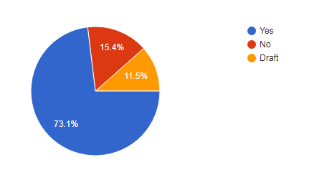

Figure 1: Analysis of code of conduct

In the figure, we see that 73.1% of organizations have their written ethics policy and 11.5% have a draft code conduct.

**Honesty:** Honesty is also a major concern in business organizations. Through the survey, we found that every organization gives an attention to the honesty of the employees and managers. We collected different data on honesty in our survey.

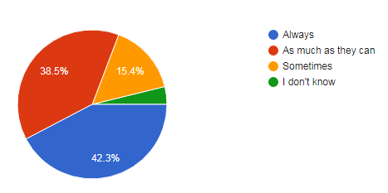

Figure 2: Analysis on the honesty of the managers

We found that 42.3% of managers always behave honestly.38.5% wants to treat honestly as their capability and 15.4% of them behave honestly sometimes.

**Green Computing:** Green computing also observed as an ethical issue in the organizations. It is important for all kind of system of any scale [8]. Green computing defines the production of safe products for the environment and people. The effect of activities of the organization also included in green computing.

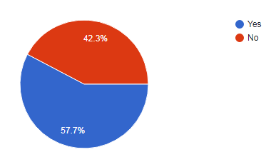

Figure 3: Green computing in organizations

So, we observed 42.3% of organizations having a policy on green computing. The statistics on response also showed that 76.9% of the organizations follow policy to produce safe and effective product and others sometimes follow this policy. Survey also shows that 50% of organizations strongly agree that their products are safe, 34.6% agree and 15.4% neutral about this.

**Whistleblowing:** Whistleblowing is also a concern for the business organizations. A whistleblower (also written as a whistle-blower or whistle blower) is a person who exposes any kind of information or activity that is deemed illegal, [unethical](https://en.wikipedia.org/wiki/Ethics), or not correct within an [organization](https://en.wikipedia.org/wiki/Organization) that is either private or public [9]. The survey found some issues on this.

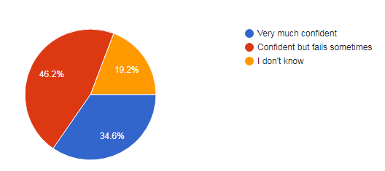

Figure 4: Analysis on whistleblowing control

The analysis shows that 46.2% of organizations confidently control whistleblowing but fails sometimes, 34.6% control very much confidently and others don’t give answer about this.

**Software Piracy:** In most organizations, software piracy is one of the major issues. Pirated copy of the software is illegal to use.

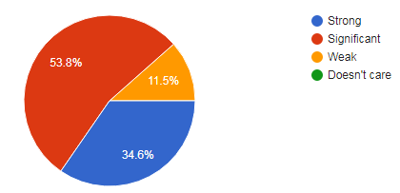

Figure 5: Software piracy control level

The analysis shows that 34.8% of organizations strongly control software piracy, 53.8% significantly, 11.5% weakly control piracy level.

**Data Sharing:** Each company uses the data of mass people. They store huge amount of data in their storage. Sharing these data for business is another ethical issue.

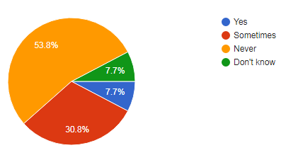

Figure 6: Rate of Data sharing for the extra benefit

The analysis shows that 53.8% never share data for the benefit, 30.8% sometimes share for extra benefit, 7.7% don’t know about it and 7.7% share data for the benefit.

**Pluralism:** It is found from the survey that pluralism exists in all kind of business organization covered by the survey. For pluralism, different issues are created in business organizations. So, this is one of the important ethical issues.

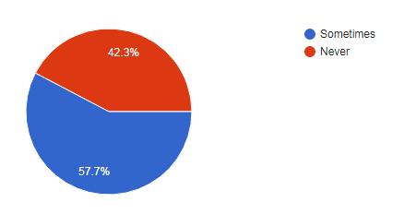

Figure 7: Pluralism in organizations

From the figure 7, we can see that 42.3% organizations never face or make different behavior for pluralism and others face.

## 2.Ethical Practices at Workplace

Business Ethics roughly refers to the application of ethical values to business behavior. Honesty or Integrity is a core value as well as one such ethical value. It answers a large part of business ethics practice in an organization.

We asked the respondents of our survey for some integrity related questions of how these are practiced in their organization.

Some of these statically analysis are highlighted below,

Figure 8: Nepotism in business organizations

According to the response of the respondents, around 34.6 percent of total respondents say that some special employees are shown nepotism to their favor. Besides, one-fourth employees of survey participators have confirmed that their leaders show nepotism in some specific sector. Besides, 38.5 percent of among participator admit that their leader is free from this being occurrence.

Figure 9: Pressure felt by the employee when an unethical task is imposed.

In a good organization, it is expected not to impose any unethical behavior on an employee to perform. But if intentionally imposed by anyone on someone, that victim person must feel pressure to perform so. We raise this question to the correspondent to know their feelings. 36 percent of people feel huge pressure, 52 percent of employees feel average pressure. There are also 12 percent people who don’t care anything.

Figure 10: Strictness of organization on an unethical behavior

34.6 percent employees think, their organization does no compromise to an unethical behavior and it goes on a direct action. Around 57.7 percent of employees know that their organization is loose to the rules depending on the situation. But there still 7.7 percent of employees who think their organization is loose enough to be strict on an unethical behavior and overlook the situation.

Figure 11: Created issues for whistleblowing

A bad practice of an organization is whistleblowing. We’ve asked out among the respondents whether any incident related to whistleblowing occurred in their organization or not. One-fourth of them, around 24 percent think YES. One-third think of them directly deny that their organization is completely free from happening to this. 44 percent actually don’t know about this.

Figure 12: How much Feel free to Data Sharing

## 3. Supporting Ethical Issues at Organization

This section of the report takes an overview at how organization supports different ethical issues. Participants were asked whether their organization have any written ethics policy. They were also asked how their organization treat on unethical conduct.

Further different questions were also asked to overview how organization supports ethical issues.

### Ethical policy at organization

Respondents were asked whether their organization follows any ethical policy to support different ethical issues. Almost two-thirds of respondents (73%) indicated that their organization follows different ethical policy. And 15% of respondents indicated that their organization does not follow any ethics policy. Moreover, 11% of the respondents indicated that they follow some ethics policy but not strictly.

The majority of the respondents say that they have followed ethical policy in their organization.

Figure 13: Ethical policy in business organization

### Code of conduct

Respondents were asked whether it is necessary for employees to sign code of conduct statements in the organization. Above half of the respondent (53.8%) are indicated that they have signed code of conduct in organization. And 34.6% respondents indicated that they have signed code of conducts for some special case. Moreover, 11.5% of the respondents indicated that they do not have signed any code of conducts statements.

Figure 14: Code of conduct statements in business organization

### Trained ethical knowledge

To support ethical issues in business organization, it is important to trained employees about ethical knowledge and behavior. In competitive business world its necessary to treat customer more ethically. So, in our survey, we asked the respondents whether the organization require trained ethical knowledge. About 46.2% of the respondents indicated that their organization requires ethical knowledge training. And 34.2% of the respondents indicated that they do not need any training about ethical knowledge. Moreover, about 19.2% of the respondents indicated that their organizations require training on ethical knowledge.

Figure 15: Require Ethical knowledge training

### Monitoring Unethical Activities

In business organizations, every employee should behave ethically. Because it is necessary to create a good working environment in the organization. There are some common unethical behaviors that observed in the organization. For example, Misusing company time, Abusive behavior, Employee theft, lying to managers, violate company internet policies.

We asked the respondents whether their organization have any monitoring system for the employee’s unethical activities. Above half of the respondents (57.7%) indicated that their organizations maintain a monitoring system for the employee’s unethical activities. And 23.1% of the respondents indicated that their organizations maintain a monitoring system for employee’s unethical activities in some sectors. Moreover, 19.2% of the respondents said No on that questions.

Figure 16: Monitoring system in business organization

### Penalty System against Unethical Behavior

As unethical behavior is not accepted from employees in the business organization. So, unethical behavior needs to be punished so that all employees behave ethically and make a good work full environment. For that, on our survey, we asked the respondents whether there any penalty system against unethical behavior in organization. Above two-third of the respondents (84.6%) indicated that they have penalty system in their organization. And 15.4% of the respondents indicated that they do not have any penalty system.

Figure 17: Penalty system against unethical behavior

### Integrity in Organization

Organization integrity is mainly ethical integrity of individual employees, ethical quality in their actions and decision making. To make an advantage of competitive business world, every employee in the organization should act with integrity. So, organization need to encourage employee or rewarded employee to work with integrity. So, we ask the respondents whether their integrity rewarded in their organization. About 15.4% of the respondents indicated that they have always rewarded. About 38.5% of the respondent indicated that they have rewarded most of the time. And 38.5% of the respondents indicated that they have rewarded sometimes in the organization. Moreover, about 7.7% of the respondents indicated that they never gain any rewarded.

Figure 18: Integrity rewarded percentage in organization

### Control on Whistle Blowing

Whistle Blowing is an effort to attract public attention to a negligent, illegal, unethical, abusive or dangerous act by a company [10]. It is an important ethical issue for individuals and organization. So, we asked the respondents how much their organization confidentially control on whistle blowing. About 34.6% of the respondents indicated that their organizations are very much confident. Almost half of the respondents (46.2%) indicated that their organization are confident but fails sometime. And 19.2% of the respondents said that they do not know about this.

Figure 19: Control on whistle blowing

### Importance on software piracy

Respondents were asked how much importance their organizations give on software piracy. Above half of the respondents (53.8%) indicated that their organizations give significant importance on software piracy. About 34.6% of the respondents indicated that their organizations give strong importance and 11.5% indicated weak importance on software piracy.

Figure 20: Importance on software piracy

### Avoiding Unfavorable publicity

Unfavorable publicity is another ethical issue that needs to support in the business organization. So, we asked the respondents whether their organizations follow any policy to avoid unfavorable publicity. Above half of the respondents (56%) indicated that they have the policy to avoid unfavorable publicity. About 24% of the respondents indicated that they do not follow any policy. And 20% of the respondents indicated that they may have some policy.

Figure 21: Avoid unfavorable publicity

### Risk Assessment policy

Risk assessment policy for the business organization is the set of procedures or steps that will be taken to provide with their employees with least amount of risks when they performing their jobs. The procedure may be including employee training, good working environment and upgrade quality products. We asked the respondents whether their organizations maintain any ethical risk assessment policy. About 65.4% of the respondents indicated that they have risk assessment policy. About 30.8% of the respondents indicated that they do not have any policy and other indicated they do not care about any risk assessment policy.

Figure 22: Ethical risk assessment policy

# V. Findings

From the analysis of the collected data, overall positive view of ethical practices is observed in business organizations. The employees show honesty in workplace. Survey shows that 42.3% employees always show honesty, 38.5% show honesty as much as they can show and 15.4% sometimes show honesty in workplace. About 46% of the organizations protect whistle blowing with confidently but fails sometimes and 34% handle it with very strictly. In ethical practices, nepotism is found significantly in the organizations. 36% of the organizations show nepotism to some employees, 26% in some sectors and 38% never show nepotism. In case of software piracy 34% of the organizations give strong concern, 53% give significant and 11% give a weak concern. For the support of ethical standards, about 73% of the organizations have a code of conduct.

# VI. Conclusion

In this survey, we have tried to find out the attitudes and perception of the employees and managers in an organization. Especially, how they behave toward the organization with ethical standards and how the organizations maintain ethical issues. There were total 28 responses from 12 organizations. So far we have found through our survey, it helped to analyze the state of the ethical perspectives of the business organizations.

# VII. Acknowledgment

We, the authors of the survey would like to thank cordially to the Co-Author for his help and direction. Then gratitude goes to Institute of Information Technology, University of Dhaka for giving us the scope to make the survey. We also thank to the employees of different organizations for their cooperation. As we analyzed some existing survey, we are also grateful to them.

# REFERENCES

#### 1. [List of Ethical Issues in Business | Chron.com](https://smallbusiness.chron.com/list-ethical-issues-business-55223.html)

#### 2. Deniel J., Ethics at Work 2015 survey of Employees Britain, ibe

#### 3. Robert W. Cates, David J. MacCabe, Beverly H. Williams, Survey on Ethics and Governance, 2006 The IIA Research Foundation

#### 4. A Global Study of Business Ethics 2005-2015, American Management Association/Human Resource Institute

#### 5. Victoria W., Muhammad M. A., Trevor W., Ethical conduct in business: a case study analysis using Bangladesh experiences, Problems and Perspectives in Management, Volume 8, Issue 4, 2010

#### 6. [Google Form – create and analyze surveys, for free](https://www.google.com/forms/about/)

#### 7.  [IFAC](http://www.ifac.org/)

#### 8. S. Mittal, "[A survey of techniques for improving energy efficiency in embedded computing systems](https://www.academia.edu/4186102/A_survey_of_techniques_for_improving_energy_efficiency_in_embedded_computing_systems) [Archived](https://web.archive.org/web/20151004011859/http:/www.academia.edu/4186102/A_survey_of_techniques_for_improving_energy_efficiency_in_embedded_computing_systems) October 4, 2015, at the [Wayback Machine](https://en.wikipedia.org/wiki/Wayback_Machine).", IJCAET, 6(4), 440–459, 2014.

#### 9. Vandekerckhove, Wim (2006). Whistleblowing and Organizational Social Responsibility: A Global Assessment. Ashgat.

#### 10. [Comp Ethics Ch 10 Flashcards | Quizlet](https://quizlet.com/109236152/comp-ethics-ch-10-flash-cards/)

# Appendix

**The survey questionnaire**

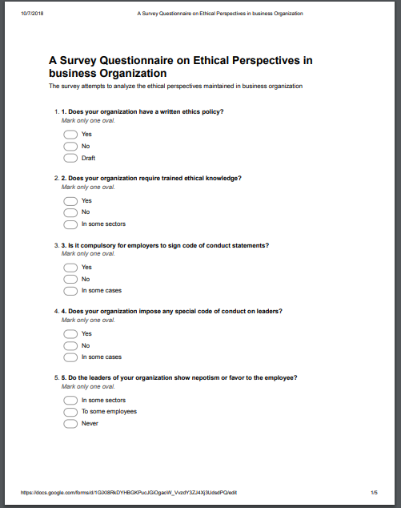

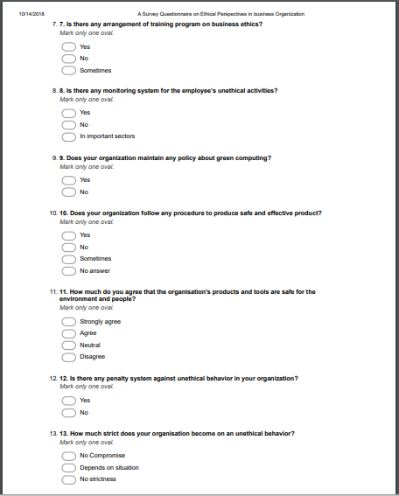

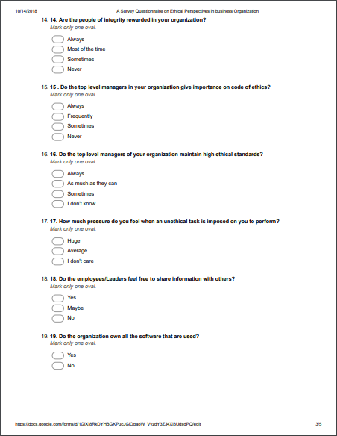

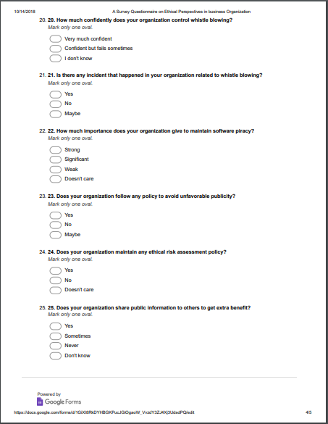

**Authors**

Ibrahim Khalil, born on 9 November 1996. He is currently a student of Institute of Information Technology, University of Dhaka. He passed H.S.C from Abdul Kadir Molla City College.



Tulshi Das, born on 5 February 1997. He is currently a student of Institute of Information Technology, University of Dhaka. He passed HSC from Abdul Kadir Molla City College.

Maloy Kanti Sarker, born on 5 may, 1997. He is currently a student of Institute of Information Technology, University of Dhaka. He passed HSC from [Notre Dame College, Dhaka, Bangladesh](https://www.facebook.com/pages/Notre-Dame-College-Dhaka-Bangladesh/427105287386193?eid=ARCQqiQW3ipfVmb0L2X6_UezknCiKSv7JNdhZi8NNyT2nHxrMSnSbbEn7iP68UZHKpGp5Wo5z0J413DZ).

**Co-author**

[Rezvi Shahariar](http://www.iit.du.ac.bd/about_iit/individual_teacher/51), Assistant Professor, Institute of Information Technology, University of Dhaka. He received his B.S in Computer Science. He led many research on ethical issues in business organizations. He played a role as a co-author in many ethical surveys in business organizations of Bangladesh.